**Insert Element**

**Append**

parent.appendChild(el);

// or

parent.insertAdjacentElement(‘afterend’, el);

**Prepend**

parent.insertBefore(el, parent.firstChild);

// or

parent.insertAdjacentElement(‘beforebegin’, el);

**Insert element string**

Systax:

element.insertAdjacentHTML(position, text);

position:

* Beforebegin: before the element itself
* Afterbegin: just inside the element, before its first child
* Beforeend: just inside the element, after its last child
* Afterend: after the element itself

Visualization of position names:

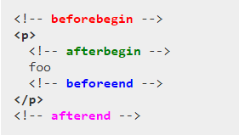

Note: The beforebegin and afterend positions work only if the node is in the DOM tree and has a parent element.

Example:

**Before**

el.insertAdjacentHTML(‘beforebegin’, htmlString);

**After**

el.insertAdjacentHTML(‘afterend’, htmlString);